SIMATS ENGINEERING

Department of Computer Science and Engineering

ASSESSMENT TOOL 1 – INDUSTRY PROBLEM SOLVING TASK

Course Code: | CSA12 | Course Title: | Computer Architecture
CO Assessed: | CO4 – Precision (BL4) | Assessment: | Industry Problem solving task
Weightage: | 30% | Total Marks: | 100
CO4 Statement: | Implement hierarchical memory systems by differentiating cache levels (L1, L2, L3), virtual memory with paging, and advanced memory technologies (DRAM, SRAM, NAND Flash, MRAM, RRAM) based on latency, bandwidth, and throughput characteristics.
Student Name: | A.KULLAI REDDY | Reg. No.: | 192412647
Section / Batch: | 2024 | Date: | 19/08/2026
Instructions to Students
- Identify the relevant concepts of cache hierarchy, SRAM, DRAM, MRAM, NAND Flash, RRAM, memory latency, bandwidth, and virtual memory paging.
- Analyze the memory-access requirements of smartphones, cloud servers, autonomous vehicles, edge AI devices, and gaming consoles, considering latency, bandwidth, capacity, and power consumption.
- Apply suitable memory-hierarchy techniques such as cache optimization, appropriate memory technology selection, data locality, paging optimization, and hierarchical memory organization.
- Compute performance measures such as memory access time, latency, bandwidth, throughput, speedup, hit/miss rates, and resource or power utilization where applicable.
- Interpret the results by evaluating performance improvements, memory bottlenecks, technology trade-offs, and the suitability of the proposed memory hierarchy for each application.

QUESTIONS
- A high-frequency financial trading system must process large volumes of market data with extremely low response time. Analyze the roles of CPU caches, DRAM, and persistent storage in handling frequently accessed trading data. Considering latency, data locality, capacity, and bandwidth, propose a memory hierarchy that minimizes data-access delays and supports high transaction throughput.
- A medical imaging workstation processes large CT and MRI datasets while simultaneously running image-enhancement and visualization applications. Evaluate the interaction between cache memory, DRAM, and high-capacity storage during image processing. Propose an optimized memory hierarchy that balances access latency, memory capacity, bandwidth, and cost to improve overall processing performance.
- A smart surveillance system receives continuous video streams from multiple high-resolution cameras and must detect objects in real time. Analyze the memory requirements for storing video frames, intermediate processing data, and frequently accessed detection parameters. Compare cache, DRAM, and non-volatile memory technologies and design a hierarchy that minimizes memory bottlenecks while maintaining high data throughput.
- A scientific computing system performs large-scale simulations involving matrices and continuously accessed numerical datasets. Analyze how cache capacity, data locality, cache misses, DRAM bandwidth, and memory latency affect the execution of computational kernels. Recommend memory-hierarchy improvements that can reduce cache misses, increase effective memory bandwidth, and improve overall simulation performance.
- A wearable health-monitoring device continuously collects sensor readings while operating under strict battery constraints. Analyze the trade-offs among SRAM, DRAM, and non-volatile memory in terms of latency, capacity, energy consumption, and data retention. Design a memory hierarchy that provides rapid access to frequently processed sensor data while minimizing power consumption and extending battery life.

Code of Conduct
I (Name / Reg No) certify that this submission is my original work and that I have adhered to the guidelines specified for this assessment. I understand that any violation of academic integrity rules will result in disciplinary action.

Signature of the Student:

RUBRICS FOR CALCULATION

Criteria | Weightage(%) | Level 4 – Exemplary (5 Marks) | Level 3 –  Proficient (4 Marks) | Level 2 – Developing (2–3 Marks) | Level 1 – Beginning (0–1 Mark)
Understanding of Industry Problem | 20% | Comprehensive understanding of real-world problem and constraints | Good understanding with minor gaps in requirements | Basic understanding; some requirements unclear | Poor understanding; misinterprets problem context
Application of Engineering Concepts | 25% | Applies advanced and relevant concepts effectively to solve the problem | Applies appropriate concepts with minor errors | Limited application of concepts | Incorrect or no application of concepts
Solution Design | 25% | Innovative, practical, and feasible solution aligned with industry standards | Logical and feasible solution with minor gaps | Basic solution with limited feasibility | Unclear or impractical solution
Use of Tools | 15% | Effective use of modern tools, technologies, and real data | Appropriate use of tools with correct implementation | Limited or inconsistent use of tools | Minimal or incorrect use of tools
Analysis | 10% | Thorough analysis with validated results and performance evaluation | Good analysis with reasonable validation | Basic analysis with limited validation | Poor or no analysis
Professionalism | 5% | Highly professional, well-documented, and clearly presented work | Good documentation and presentation | Basic documentation with some gaps | Poor documentation and presentation

Marks Evaluation:

Q.  No | Understanding of Industry Problem (20) |  | Application of Engineering  Concepts (25) |  | Solution Design (25) | Use of Tools  (15) | Analysis (10) | Professiona lism(5) | Total (out of 100)
1 | / 4 |  | / 4 |  | / 4 | / 4 | / 4 | / 4
2 | / 4 |  | / 4 |  | / 4 | / 4 | / 4 | / 4
3 | / 4 |  | / 4 |  | / 4 | / 4 | / 4 | / 4
4 | / 4 |  | / 4 |  | / 4 | / 4 | / 4 | / 4
5 | / 4 |  | / 4 |  | / 4 | / 4 | / 4 | / 4
 | / 25 |  | / 30 |  | / 20 | / 15 | / 10 |  | / 100

Course Coordinator Faculty Incharge

Memory Hierarchy & Performance Analysis
Answers to Assignment Questions: Cache, DRAM, MRAM, NAND Flash, RRAM, Latency, Bandwidth, and Virtual Memory Paging

Prepared for: Case-study questions on smartphones, cloud servers, autonomous vehicles, edge AI devices, gaming consoles, and the five application scenarios below.

Question 1: High-Frequency Trading System

Concept overview
A trading system re-reads the same order-book entries and price ticks thousands of times a second, so it lives or dies on latency, not capacity. The memory hierarchy has three layers to consider: CPU caches (L1/L2/L3 SRAM) for the hot order-book data, DRAM for the working set of market-data streams, and persistent storage (NVMe SSD/Optane) for trade logs and compliance records that must survive a crash.

Role of each layer
- CPU caches (L1/L2/L3): hold the active order book, price ladders, and hot trading-strategy variables. Nanosecond access lets the CPU react to a price tick within one clock cycle range.
- DRAM: buffers incoming market-data feeds (tens of GB/s bandwidth) and holds the full instrument universe that does not fit in cache.
- Persistent storage (NVMe SSD): asynchronously logs every trade for audit/replay; kept off the critical path so its higher latency never blocks a trade decision.

Latency comparison
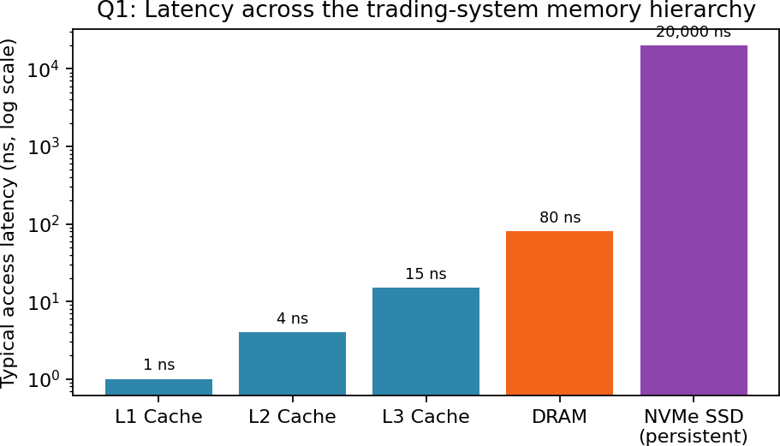

Performance computation (Average Memory Access Time, AMAT)
AMAT = Hit time + (Miss rate × Miss penalty). Example: if L1 hit time = 1 ns, L1 miss rate = 5%, and the penalty of going to L2 (15 ns) applies on a miss:
AMAT = 1 + (0.05 × 15) = 1.75 ns — about 43× faster than fetching directly from DRAM (80 ns) and roughly 11,000× faster than going to the NVMe SSD (20,000 ns) on every access. This is why keeping the order book cache-resident is the single biggest lever for throughput.

Proposed hierarchy

s small & aligned evicting each other
Layer | Holds | Optimization technique
L1/L2 cache (per core) | Active order book, hot variables | Data locality: keep instrument data structure
L3 shared cache | Cross-core shared price feeds | Cache partitioning to avoid strategy threads
DRAM | Full instrument set, feed buffers | High-bandwidth, multi-channel DRAM; huge
NVMe SSD / Optane | Trade logs, compliance records | Asynchronous write-behind logging, off the

pages to cut TLB misse

hot path

Interpretation
The dominant bottleneck in such systems is a cache miss that falls through to DRAM or, worse, storage. Keeping the working set small and cache-friendly (data locality) and prefetching upcoming ticks are far more effective than adding raw DRAM capacity. This hierarchy minimizes access delay for the hot path while still guaranteeing durability for compliance data.

Question 2: Medical Imaging Workstation

Concept overview
CT/MRI datasets are large (hundreds of MB to several GB per study) but only small regions are actively viewed or filtered at any moment. The workload therefore needs a hierarchy that balances capacity (to hold whole studies) with bandwidth (to stream voxel data to the GPU/CPU for enhancement and rendering).

Interaction of the layers
- Cache (CPU/GPU L1-L3): holds the image tile or slice currently being filtered/rendered — keeps convolution kernels and small windows cache-resident for real-time enhancement.
- DRAM: holds the full 3-D volume of the study in view, enabling fast scrolling through slices without re-reading storage; also buffers multiple concurrently open studies.
- High-capacity storage (NVMe SSD for active cases, HDD/PACS archive for older studies): provides the multi-TB capacity needed for a hospital's imaging archive at a much lower cost per GB.

Capacity vs. latency trade-off
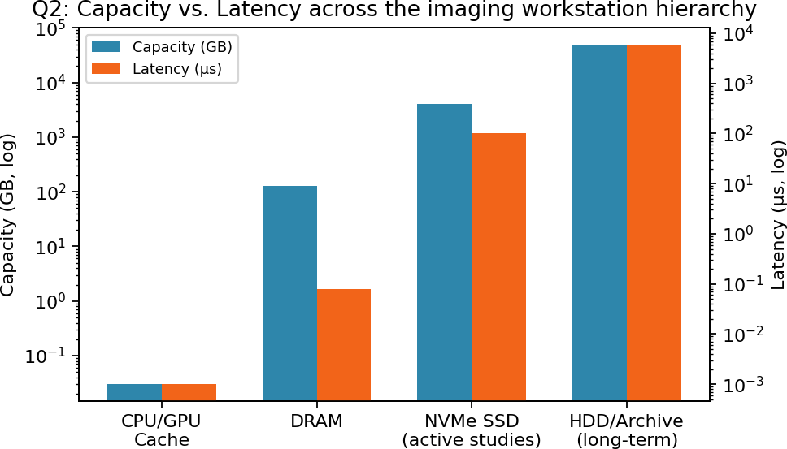

Performance measures
Throughput for opening a study ≈ dataset size ÷ effective bandwidth. A 1 GB CT volume read from an NVMe SSD at ~3 GB/s loads in roughly 0.33 s, versus several seconds from a network HDD archive at ~150 MB/s. Once loaded into DRAM (bandwidth in tens of GB/s) and cached in SRAM for the active slice, subsequent scroll/zoom operations complete in well under a millisecond.

Proposed hierarchy

Layer | Role | Technique applied
GPU/CPU cache | Active slice / filter kernel | Tiling for data locality during convolution

pression
Layer | Role | Technique applied
DRAM (large capacity) | Whole study volume in view | Prefetch adjacent slices while scrolling
NVMe SSD (hot tier) | Recently/actively opened studies | SSD caching layer in front of archive
HDD/PACS archive (cold tier) | Long-term study retention | Hierarchical storage management, com

Interpretation
An SSD hot-tier in front of the archive removes the biggest bottleneck (slow cold storage) at modest cost, while DRAM sizing determines how many studies can be held open simultaneously. This tiered design balances latency, capacity, and cost far better than an all-flash or all-cache approach would.

Question 3: Smart Surveillance System

Concept overview
Real-time object detection over multiple high-resolution camera streams must sustain high throughput (many frames/sec across many streams) while keeping latency low enough for detection to be actionable, and must not lose captured video if power or network drops — favoring non-volatile storage for that role.

Memory requirements by data type
- Video frame buffers: large, continuously overwritten — best placed in DRAM for its bandwidth and capacity; only the current frame's active region touches cache.
- Intermediate CNN activations: reused heavily within a single inference pass — kept in SRAM cache for nanosecond access, since they are accessed many times per frame.
- Detection model weights / parameters: read-mostly and frequently re-used across frames — candidates for fast non-volatile memory (RRAM) so they persist without refresh power.
- Recorded event clips / alerts: must survive power loss — written to NAND flash.

Technology comparison
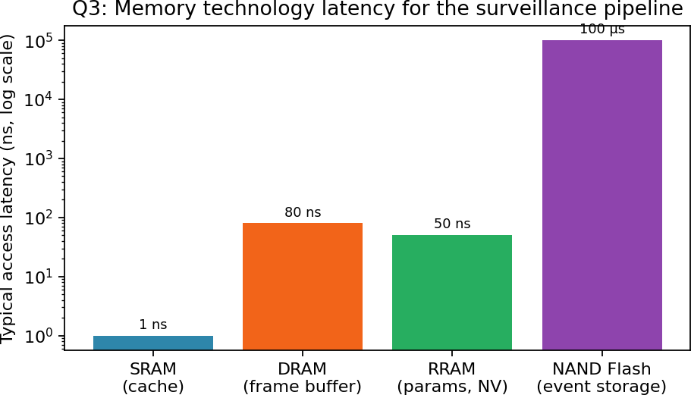

rance four
Technology | Volatile? | Typical role here | Key trade-off
SRAM (cache) | Yes | CNN intermediate activations | Fastest, smallest, most expensive/bit
DRAM | Yes | Multi-camera frame buffers | High bandwidth, needs refresh power
RRAM | No | Model weights, config | Fast non-volatile write, moderate endu
NAND Flash | No | Recorded clips, event logs | High capacity/low cost, slowest of the

Performance measure example
For 4 cameras at 1080p/30fps, raw bandwidth demand ≈ 4 × (1920×1080×1.5 bytes × 30) ≈ ~370 MB/s just for frame ingestion — comfortably inside DRAM bandwidth (tens of GB/s) but far above what NAND flash could

sustain directly, confirming frames must land in DRAM first and only be flushed to flash as compressed, lower-rate event clips.

Interpretation
The main bottleneck risk is writing raw, uncompressed video straight to flash, which would throttle the whole pipeline. Buffering in DRAM, caching hot activations in SRAM, and storing weights in RRAM for instant-on operation gives high sustained throughput while flash is reserved for compressed, lower-bandwidth archival writes.

Question 4: Scientific Computing System (Large-Scale Simulations)

Concept overview
Matrix-heavy simulation kernels (e.g., dense linear algebra, stencil codes) repeatedly touch large arrays that do not fit in cache. Performance is governed by how well the access pattern exhibits data locality — both temporal (reusing the same data soon) and spatial (using nearby data) — because that determines the
cache-miss rate, which in turn determines how often the slower DRAM path is used.

How each factor affects execution
- Cache capacity: limits how large a working set (e.g., a matrix tile) can be reused before eviction; too small a cache forces repeated DRAM trips for the same data.
- Data locality: naive row/column-major mismatches or huge stride accesses destroy spatial locality and inflate the miss rate even when the cache is large enough.
- Cache misses: each miss costs the DRAM miss penalty (tens of ns) instead of ~1 ns — with millions of accesses, even a few extra percentage points of miss rate is very costly.
- DRAM bandwidth: once data streams from DRAM, achieved bandwidth caps how fast the kernel can be fed, especially for streaming/stencil kernels with low reuse.
- Memory latency: on the critical path whenever a miss cannot be hidden by prefetching or out-of-order execution, directly stalling the compute pipeline.

Effect of improving locality (loop tiling / blocking)
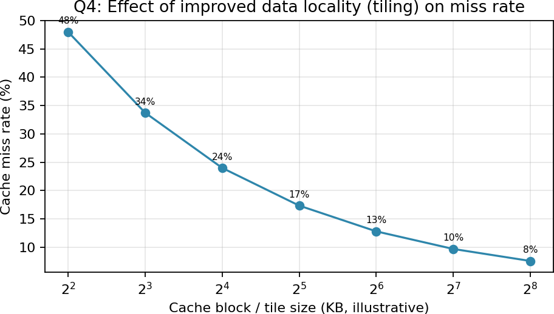
Illustrative trend: as the working tile is sized to fit the cache (blocking/tiling), the miss rate drops sharply, then flattens once the tile already fits comfortably — showing why tile size should match cache capacity rather than being maximized blindly.

Performance computation

Speedup from reducing miss rate: if AMAT_before = 1 + 0.30×80 = 25 ns and, after tiling, AMAT_after = 1 + 0.06×80 = 5.8 ns, then Speedup ≈ 25 / 5.8 ≈ 4.3× on memory-bound sections of the kernel — even though not a single instruction of arithmetic changed.

Recommended improvements

Technique | Effect
Loop tiling / blocking | Matches working-set size to cache capacity, cutting miss rate
Data layout transformation (e.g., row-major acces | sIm) proves spatial locality, fewer cache lines fetched
Prefetching | Hides remaining DRAM latency behind computation
Multi-channel / high-bandwidth DRAM | Raises the ceiling for streaming-dominated kernels
Larger shared L3 / NUMA-aware placement | Reduces cross-socket misses in multi-node simulations

Interpretation
For compute kernels like this, the memory hierarchy — not raw CPU clock speed — is usually the bottleneck. Restructuring the algorithm for locality is typically far more effective than buying faster DRAM, because it attacks the miss rate directly rather than only the miss penalty.

Question 5: Wearable Health-Monitoring Device

Concept overview
A wearable continuously samples sensors (heart rate, motion, SpO2) on a tiny battery, so energy per access and data retention without power matter as much as speed. The design must balance SRAM's speed, DRAM's bandwidth/capacity, and non-volatile memory's ability to retain data with zero standby power.

Trade-offs
Memory | Latency | Energy/access | Retention | Best use here
SRAM | Sub-ns – few ns | Very low, but leaks power when idl | eV(onleaetildes—colnosttaonnt spuo | pwpTelyirn-)oyfbf uffer for the sample cu
DRAM | ~tens of ns | Low per access, but refresh drains | bVaotltaetriylec—onltoinsutoounslpyo | wAevr-ooifdfed or minimized; only
Non-volatile (MRAM/ | RMRRAAMM/F/lRaRshA)M: ~ns–µ | sM; RFlAaMsh/R: ~RmAsMwloriwte;sFlash higher pe | rRwertiateins data with pow | Leor gogffing history & settings be

rrently being

if bulk buffering

Energy comparison
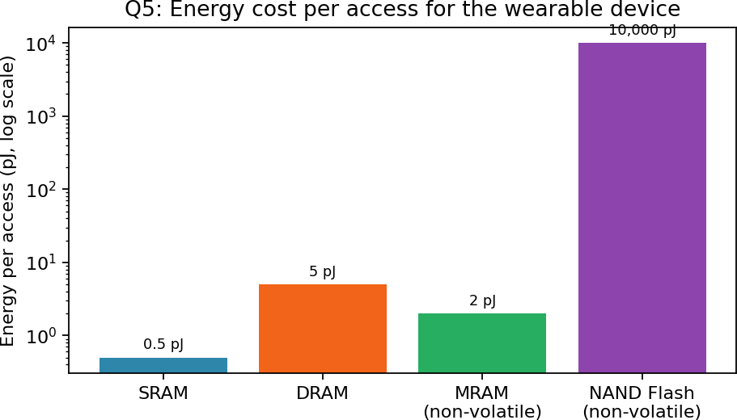

Why DRAM is minimized
DRAM needs periodic refresh (typically every ~64 ms) to retain data, which burns power even when the device is idle — a poor fit for a battery that must last days. MRAM/RRAM, by contrast, hold their state with no refresh at all, so the device can power down completely between sensor samples and 'wake up' instantly with no data loss.

Proposed hierarchy
tween charges

tation, kept minimal to
Layer | Holds | Why
Small SRAM buffer | Sample currently being filtered/processed | Fastest access for the active compu
MRAM/RRAM (main non-volatile sto | rRee) cent sensor history, calibration data, sett | inNgosrefresh power, instant-on, good

endurance for frequent

ed instantly
Layer | Holds | Why
NAND Flash (optional, bulk) | Long-term logs synced periodically to phone | L/colowuedst cost per bit for data not need

Interpretation
By replacing most of DRAM's role with MRAM/RRAM, the device avoids continuous refresh energy and can duty-cycle (sleep/wake) aggressively, which is the single biggest lever for battery life in always-on sensing wearables — at the cost of somewhat higher per-write energy than SRAM/DRAM, which is an acceptable trade given the low sampling rate.

